***AURA GOLD NEW COLLECTION:***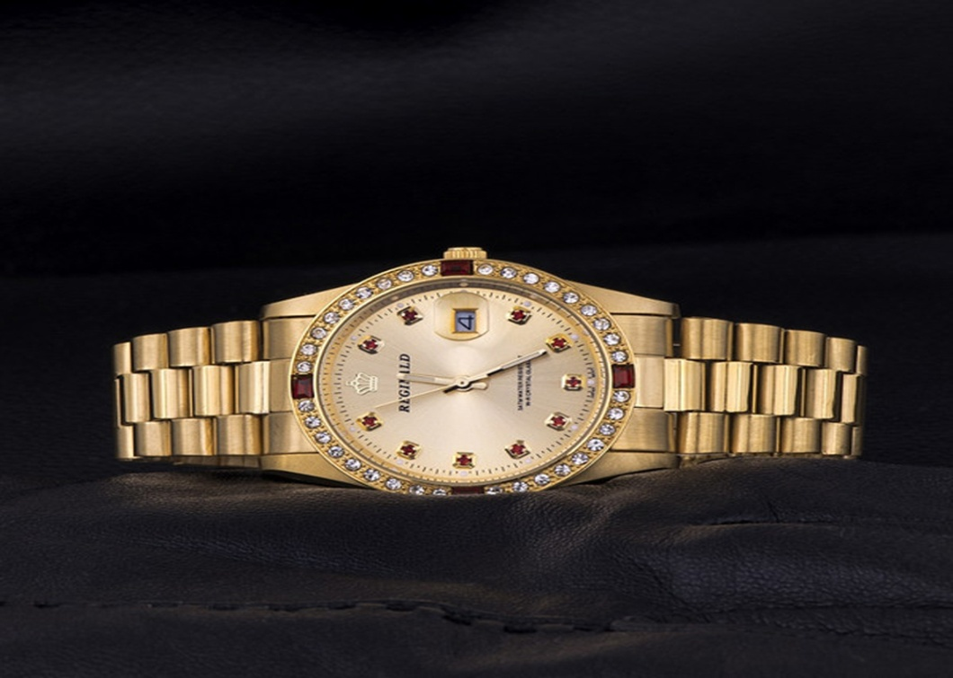

***DETAILS ABOUT THIS WATCH:***

Buckle/Clasp: Clasp (Jewelry)  
Band Color: Gold-Tone  
Case Color: Gold-Tone  
Case Finish: Polished  
Case Height: 10 mm  
Strap and Lug Width: 12 mm  
Case Material: Low Lead Brass  
Case Shape: Other  
Case Size: Small Size

***SPACES***

**DIAL COLOR:**Gold

**CASE SIZE:**24mm

**CASE SHAPE:**Round

**CASE MATERIAL:**Stainless Steel

***Price:***

***Rs:5,000***